Factorio enemy AI analysis

Worm

Worms are a stationary defense enemy found guarding enemy nests, their AI are relatively simple since they don’t move

worms will default to their idle state where they sit underground in holes. when a player or player made object i.e., a car or tank, enters their alert radius they pop up out of the ground.   
if then the player (or any player made objects) enters their attack range they begin firing at them. Worms also have predictive firing, If their target is moving they’ll fire ahead of the movement in order to compensate and land hits.

Worm state graph

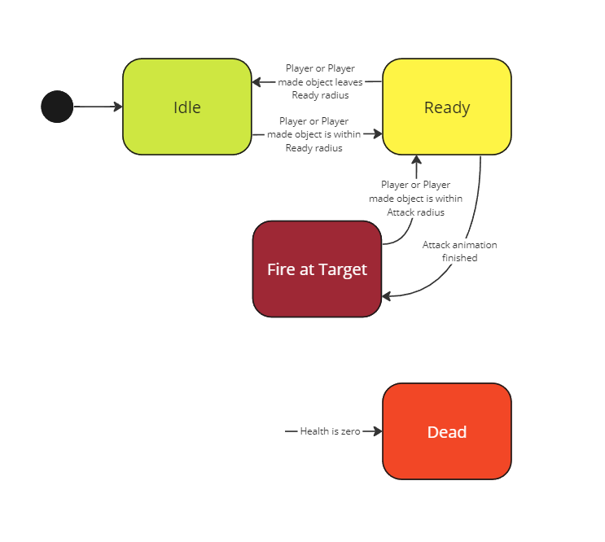

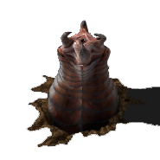

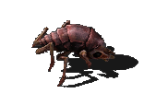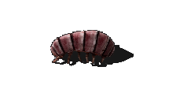Biters

Biters and Spitters (commonly referred together as Biters) are the only two mobile enemies in the game and exhibit common party behavior. Biters and Spitters both communicate with each other and together can form Attack Parties to attack player structures and Nest Parties to create new Biter nests.

If the pollution caused by the player becomes great enough, biters and spitters will wait at their nest until their numbers have grown to a large enough size (the size is determined by the evolution factor, a global value determined by pollution and game progress) they begin to march to the nearest source of pollution. This becomes their target. Once they have arrived outside of the enemy structure, always stopping some distance from player defenses like walls or turrets, they regroup and wait till either all members are accounted for or enough time has passed. Once ready they begin the attack and charge toward their target attempting to destroy everything in their path.

Biters specifically will run up directly to their target or immediate obstacle and begin dealing direct damage to them.

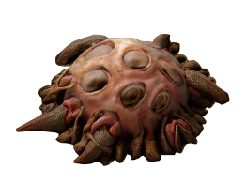Spitters specifically always keep a distance away and stand up before shooting at their target, also using predictive firing. If there are no more targets within their range they’ll go back down on all legs and continue walking forward.  
  
Both Biters and Spitters can also form Nest Parties.  
a Nest party starts every few minutes (determined by evolution factor) and if there is a valid empty space for a nest. Valid spaces are distant from other nest and distant from player structures. A similar size group to an attack party is formed and they then march together to the determined nest location. Onced all members have arrived they sacrifice themselves to become nests.

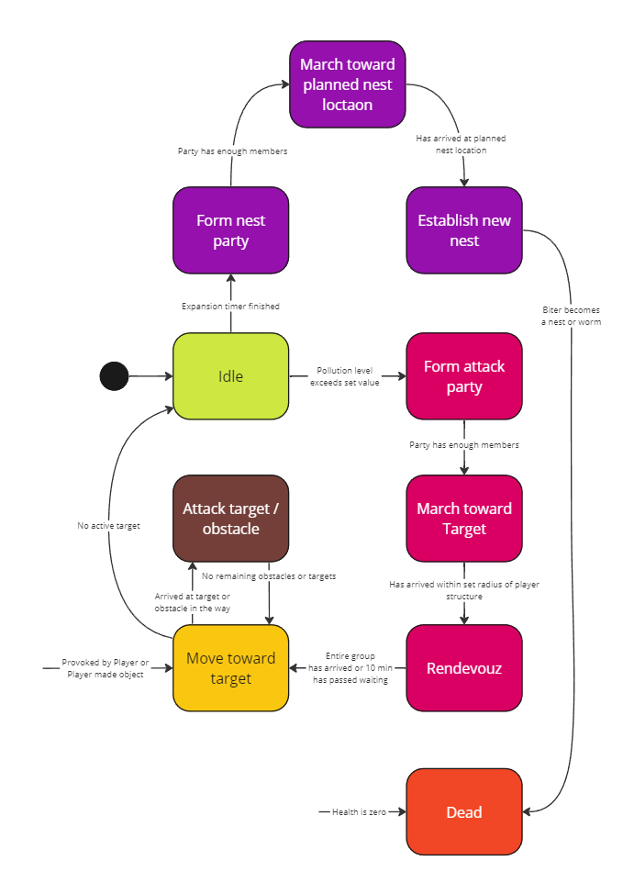Biter state graph

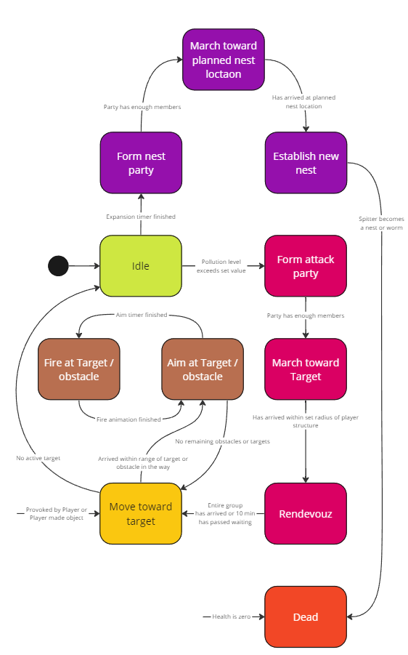Spitter state graph